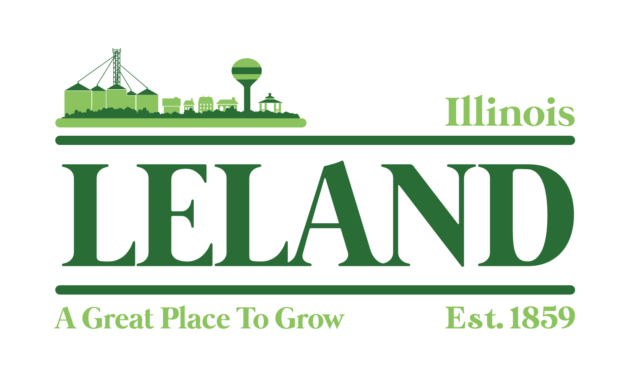
Village of Leland
Meeting Minutes of the America250 Committee
Leland Village Hall
285 West Gensesee Street, Leland, IL
July 17, 2025
5 pm
Attendees: Taunya Eckman, Jenny Wold, Marcy Kinney, Laurinda Kidd, and Jennifer Williams

- Welcome and Meeting Goals
    - Organize event days
    - Select activities
    - Assign organizations and businesses to sponsor activities
- Public Comment-Visitors, Appearances
- Event Structure
            - Celebration in July
            - Event days will be three – July 2, 3 and 4
- Activities passed on a motion by Jenny Wold and seconded by Marcy Kinney.
            - Established a tentative schedule of events:
- Thursday, July 2: Kids Day
  - Potential activities include truck displays, bounce house, tattoo station, games, water fight with the Fire Department, dunk tank and foam pit. Food options TBD
  - Laurinda Kidd to gather information on portable restrooms
- Friday, July 3
  - Partner with LTCA to host a pork chop dinner, possibly with Faye’s BBQ or 5 B’s, between 5:00 p.m. – 7:30 p.m. on Railroad Avenue.
  - Live music between 7:00 p.m. – 9:00 p.m.
  - Jennifer Williams to look into live music options
- Saturday, July 4
  - Parade at 10:00 a.m.
  - Fireworks at 9:00 p.m.
  - Additional activities between parade and fireworks TBD
- Next Steps
- Set deadlines for sponsorship, follow-ups, and activity confirmations
- The next meeting is August 23 at 9:00 a.m.
  - Plan to discuss activities on July 4
  - Estimate cost for all activities
  - Determine sponsorship opportunities
  - Assign Committee Members to approach identified sponsors
- Plan to review Touch-a-Truck, Faith Fest, and the Street Dance to discuss what went well and what did not so we can identify areas to improve as we plan for America 250

Meeting was adjourned at 6:05 p.m. on a motion by Jenny Wold and seconded by Laurinda Kidd.

"Investing in your downtown isn’t just about building for today; it’s about creating a vibrant, sustainable future that attracts people, businesses, and opportunity. A thriving downtown becomes the heartbeat of a community, driving economic growth, enhancing quality of life, and instilling a sense of pride and identity for generations to come."

