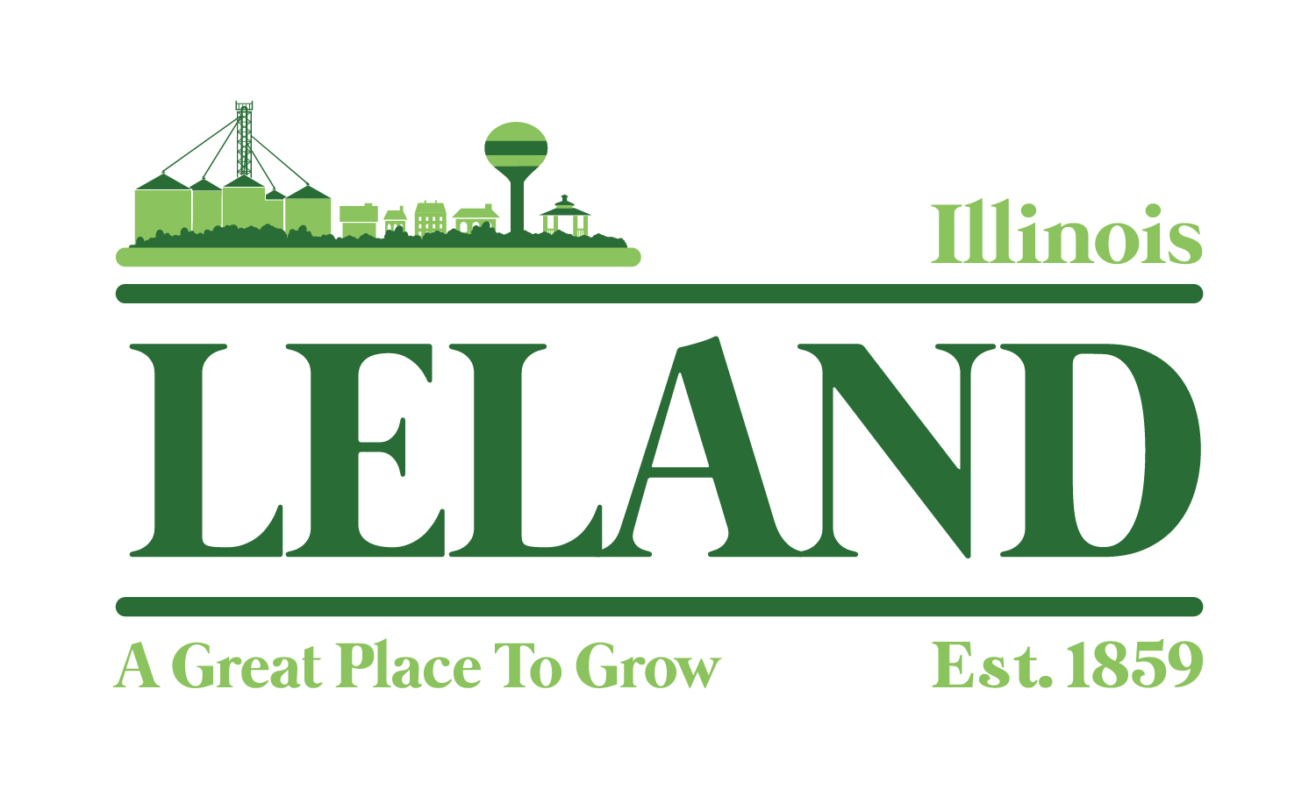
Village of Leland
Meeting of the America250 Committee
Leland Village Hall
285 West Genessee Street, Leland, IL
January 6, 2026
6 pm

- Welcome
- Public Comment-Visitors, Appearances
- Approval of Minutes: November 20, 2025
- Discuss and Plan: Stakeholders Meeting Presenter: Jennifer Williams
- Review:
- Pins/Magnets to commemorate the event
- Hayrides
- Food Trucks or local food options
- Lions Club: Dunk Tank
- Discuss: Beer Garden
- Plan next meeting
- Adjourn

"Investing in your downtown isn’t just about building for today; it’s about creating a vibrant, sustainable future that attracts people, businesses, and opportunity. A thriving downtown becomes the heartbeat of a community, driving economic growth, enhancing quality of life, and instilling a sense of pride and identity for generations to come."


