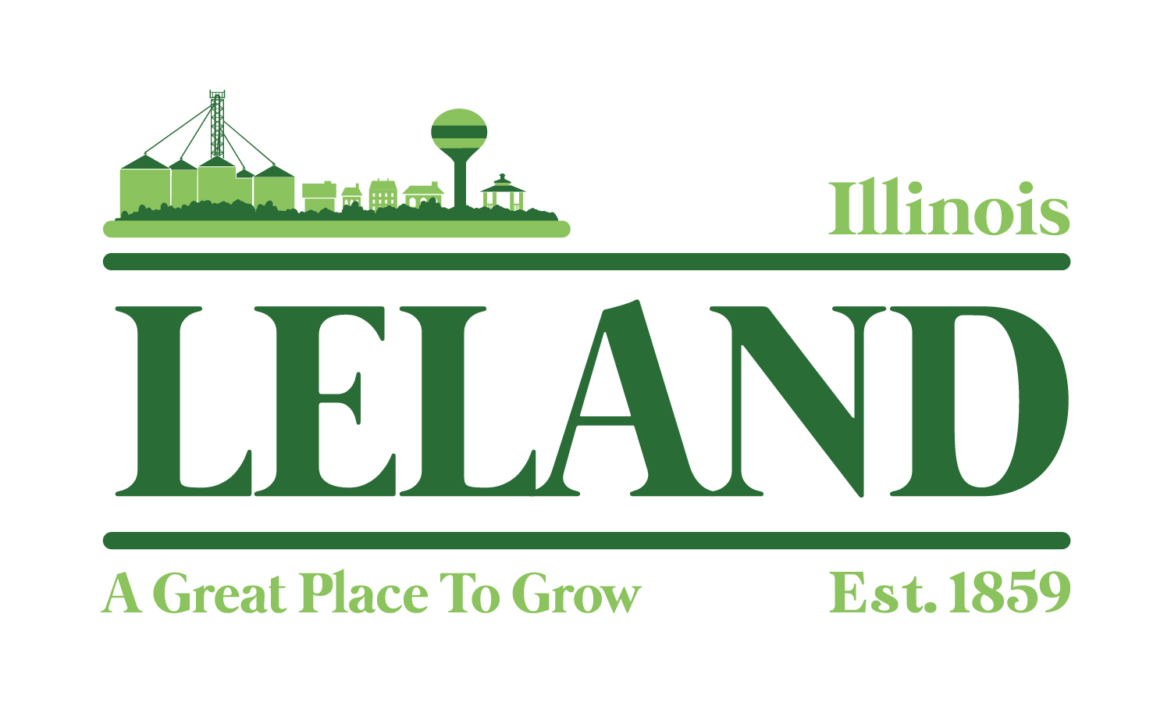
Village of Leland
Meeting Minutes of the America250 Committee
Leland Village Hall
285 West Genessee Street, Leland, IL
November 20, 2025
6 p.m.
Attendees: Taunya Eckman, Jenny Wold, Marcy Kinney, Laurinda Kidd and Jennifer Williams

- Welcome and meeting was called to order at 6:13 p.m.
- Public Comment-Visitors, Appearances - none
- Approval of Minutes: August 23, 2025. Move to next meeting.
- Discuss and Plan: Kids Day, July 2, 2026
- Laurinda and Jennifer will work on a historic walking tour of Leland and organize a scavenger hunt.
- Fire Department said yes to water fights with more details closer to the event date.
- Core Creation for foam party, ball pit and laser tag - $650
- Looking into Food Trucks or local options for food between 4-8 p.m.
- Will verify if Johnny K’s will be open by this time next year.
- Discuss and Plan: Music and Dinner, July 3, 2026
- Hop Till You Drop for inflatables for July 2 and 3 - $800
- Music band has been reserved - $700
- Discuss and Plan: July 4, 2026
- M&C Rentals for Port-a-Potties – all three days. Gathering pricing.
- Looking into pins and/or magnets to commemorate the event – gathering prices and designs.
- Looking into anyone available to provide hayrides
- Looking into prices for patriotic banners for the light poles.
- Total to date is $2650 and all ideas passed on a motion by Jenny Wold and seconded by Jennifer Williams.
- Discuss Organizations and Sponsorship and Deadlines – received many interested parties for sponsorship but have not confirmed dollar amounts yet.
- Plan next meeting
- Next meeting date will be January 6
- Approval of minutes from August 23, 2025, and November 6, 2025
- Stakeholders’ Meeting presentation which is scheduled for January 20, 2026.
- Sponsorship follow-up
- Meeting was adjourned at 7:31 p.m. on a motion by Laurina Kidd and seconded by Jenny Wold.

"Investing in your downtown isn’t just about building for today; it’s about creating a vibrant, sustainable future that attracts people, businesses, and opportunity. A thriving downtown becomes the heartbeat of a community, driving economic growth, enhancing quality of life, and instilling a sense of pride and identity for generations to come."


